**ML2021Spring HW11 Report**

Material Science and Engineering Hou, Yu-Chien

B08507012

|  |  |
| --- | --- |
| **Public Score** | **Private Score** |
| 0.79744 | 0.79760 |

The methods I used to pass the boss baselines include:

1. I added an extra layer to FeatureExtractor() to increase model complexity.
2. I trained more epochs (1000 epochs) than the default 200 epochs to make the accuracy

stabler, and it indeed raised the accuracy.

1. 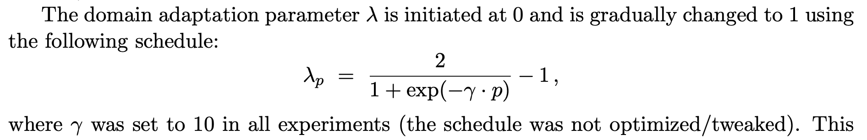I used adaptive lambda for training and constructed it according to the paper：

where *p* is a variable changing linearly from 0 to 1.

Paper：<https://arxiv.org/pdf/1505.07818.pdf>